**CDAC Mumbai PG-DAC August 24**

**Assignment No- 4**

1. Write a program that demonstrates widening conversion from int to double and prints the result.

public class Main {

public static void main(String[] args) {

int myInt = 10 ;

double myDouble;

myDouble = myInt;

System.***out***.println("Integer value: " + myInt);

System.***out***.println("Double value: " + myDouble);

}

}

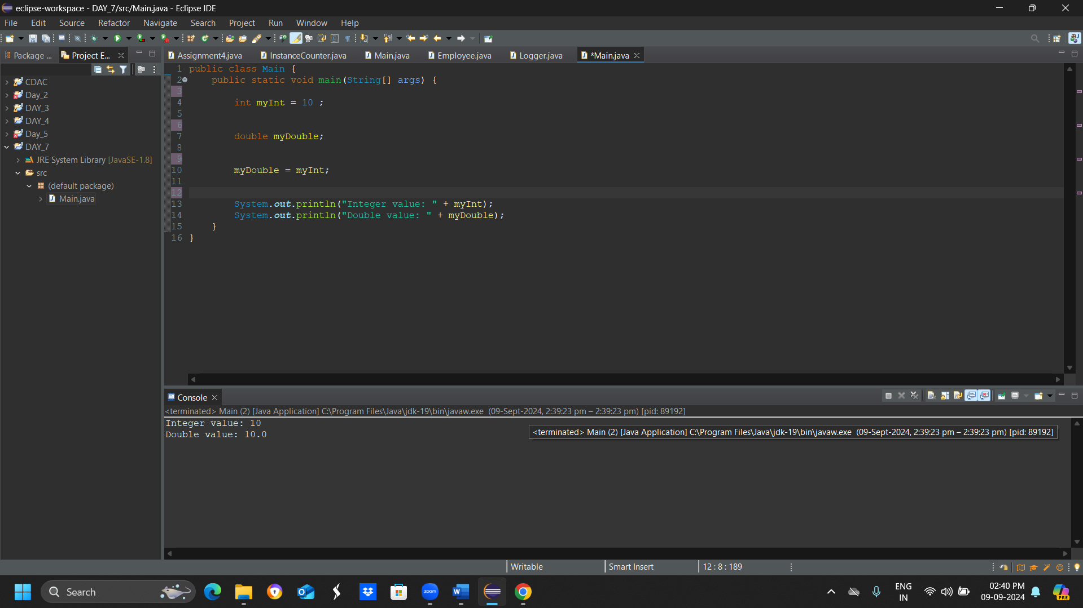

1. Create a program that demonstrates narrowing conversion from double to int and prints the result.

public class NarrowingConversion {

public static void main(String[] args) {

double doubleValue = 10.99;

int intValue = (int) doubleValue; // narrowing conversion

System.***out***.println("Original double value: " + doubleValue);

System.***out***.println("Converted int value: " + intValue);

}

}

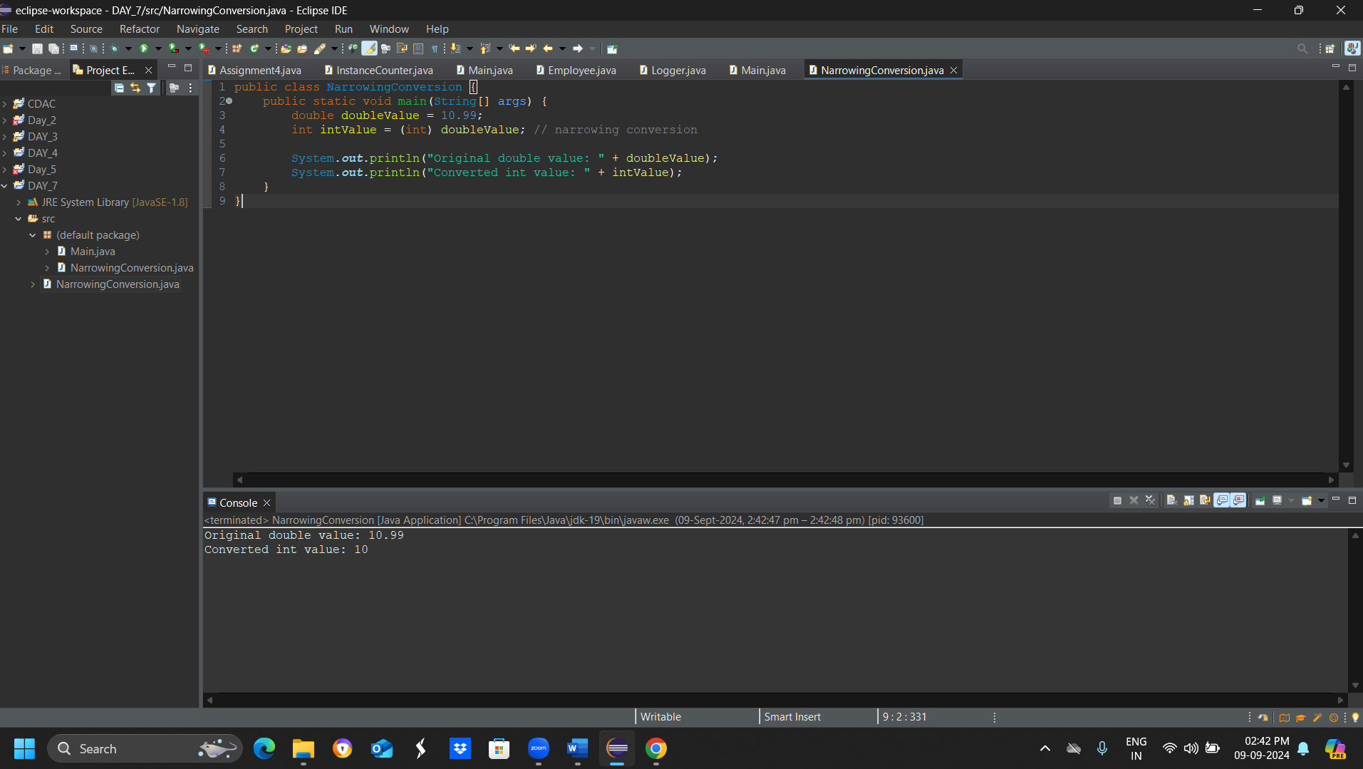

3) Write a program that performs arithmetic operations involving different data types (int, double, float) and observes how Java handles widening conversions automatically.

public class ArithmeticOperations {

public static void main(String[] args) {

// Declare variables of different data types

int intVar = 10;

double doubleVar = 20.5;

float floatVar = 30.7f;

// Arithmetic operations with int and double

double result1 = intVar + doubleVar;

System.***out***.println("int + double = " + result1);

// Arithmetic operations with int and float

float result2 = intVar + floatVar;

System.***out***.println("int + float = " + result2);

// Arithmetic operations with double and float

double result3 = doubleVar + floatVar;

System.***out***.println("double + float = " + result3);

// Arithmetic operations with int, double, and float

double result4 = intVar + doubleVar + floatVar;

System.***out***.println("int + double + float = " + result4);

}

}

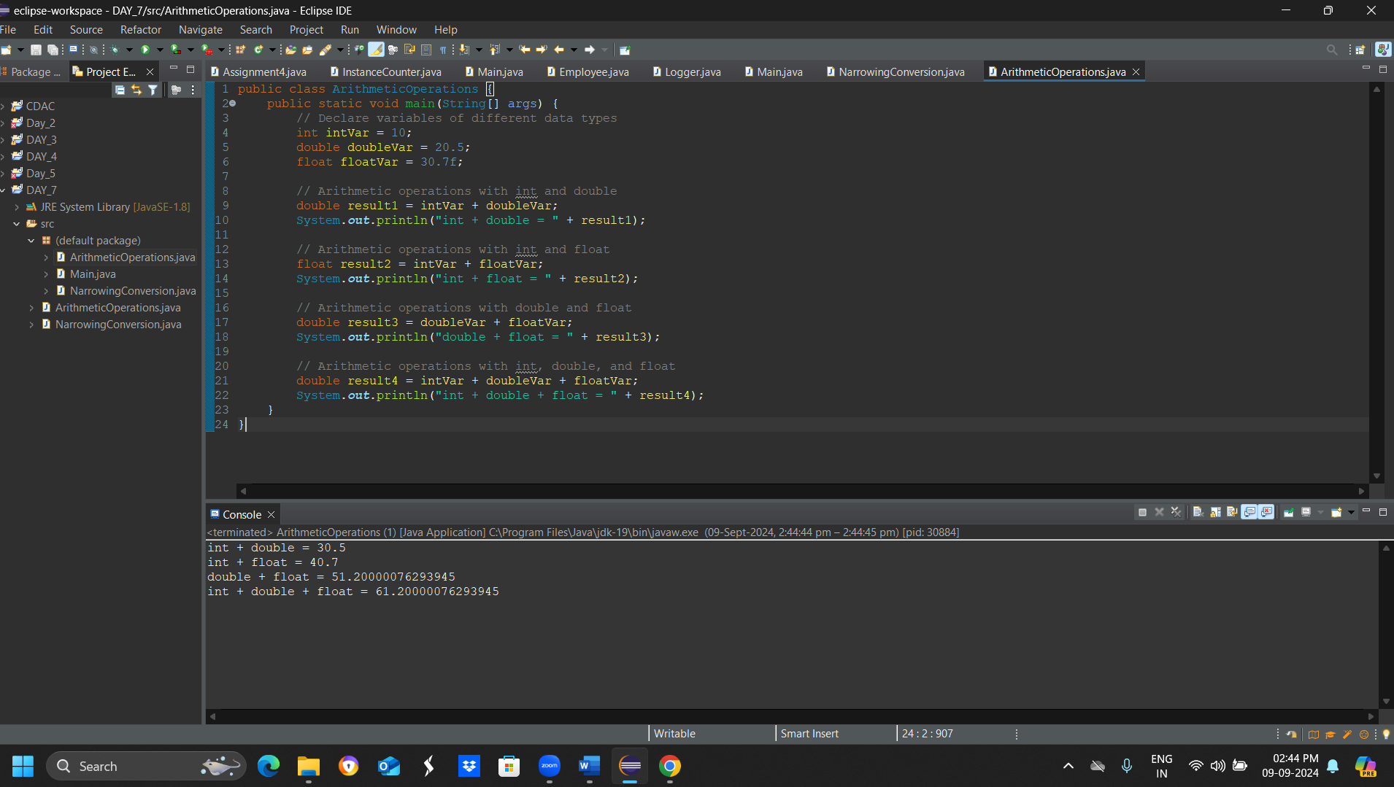

1. Write a Program that demonstrates widening conversion from int to (double,float, boolean, string) and prints the result.

public class WideningConversion {

public static void main(String[] args) {

// Widening conversion from int to double

int intVal = 10;

double doubleVal = intVal; // automatic widening conversion

System.out.println("Widening conversion from int to double: " + doubleVal);

// Widening conversion from int to float

float floatVal = intVal; // automatic widening conversion

System.out.println("Widening conversion from int to float: " + floatVal);

// Widening conversion from int to String

String strVal = Integer.toString(intVal); // manual conversion

System.out.println("Widening conversion from int to String: " + strVal);

}

}

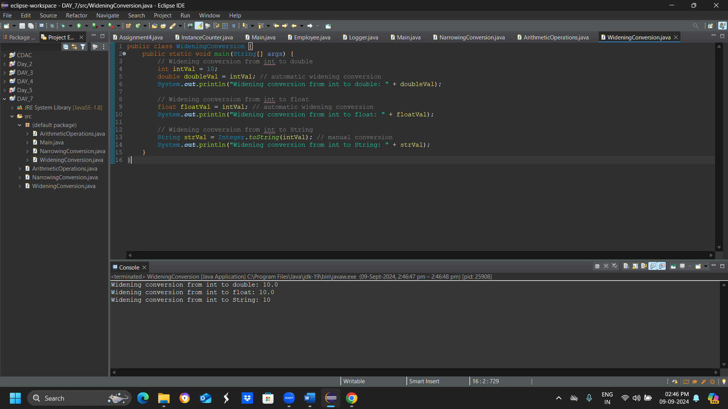

**Interview Questions**

**Note: Write down this interview question on your notebook ,Take a screenshort & Paste that SS in the word document & upload on your Github.**

**What does the static keyword mean in Java? Explain the difference between static and non-static methods.**

1. What is the role of the static keyword in the context of memory management.
2. Can static methods be overloaded and overridden in Java?Howstatic variables shared across multiple instances of a class?
3. What is the significance of the final keyword in Java?
4. What are narrowing and widening conversions in Java?
5. Provide examples of narrowing and widening conversions between primitive data types.
6. How does Java handle potential loss of precision during narrowing conversions?
7. Explain the concept of automatic widening conversion in Java.
8. What are the implications of narrowing and widening conversions on type compatibility and data loss?